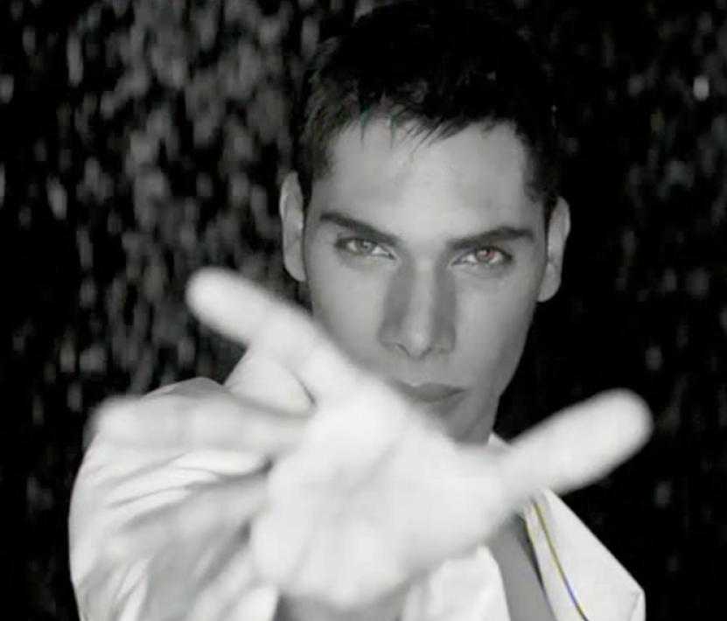
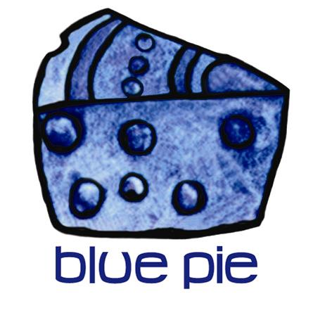

FEB 2007 SHOCKWAVE PLAYS FAIR DAY TO GREAT WELCOMING

International pop star SHOCKWAVE has made his mark in Sydney. After an action packed show at this year's Fair Day held at Victoria Park on Sunday 18th February, his name will only become more momentous.

On stage with his sonorous voice, tight pants and knock out dancers SHOCKWAVE performed his soon to be released single 'Sex Tips' from his forthcoming album '...any good looking red heads out there'. The audience was hooked by this electric original but excitement heightened when he performed his own re-mixed version of "Here Comes The Rain Again" a classic by the Eurythmics.
SHOCKWAVE concluded his first Fair Day experience by signing autographs and surprising any redheads with an exclusive pre-release signed copy of his album!

Check out photos, latest news or where to buy his music at www.shockwavemusic.net

CONTACT: Gabby Demichelis
Marketing Manager
T: +612 9011 8008
M: 0416 898 171
gabby@bluepie.info

BLUE PIE PRODUCTIONS
www.bluepie.com.au

# # #

